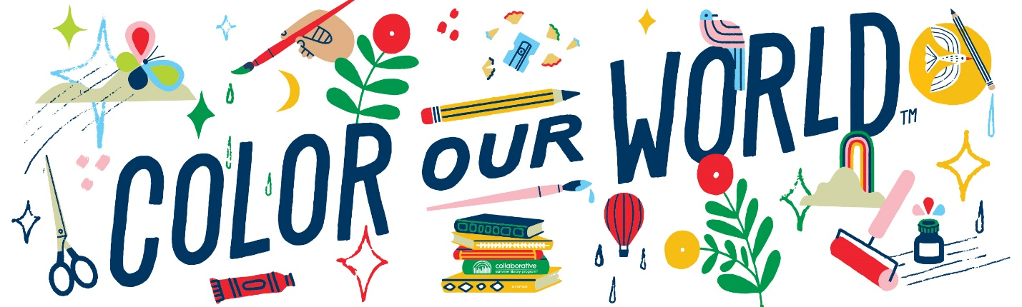

**Welcome to Summer Reading 2025!**

We are so excited for you to join us for another year of Summer Reading! Live performers are back this year featuring dinosaurs, raptors, and aquatic animals. We will also be having several creative days at the library followed by an end of the year party and the prize giveaways! Don’t forget there is also a monthly Storytime and Lapsit program. Check our Facebook page at Baldwin Public Library-Wisconsin or baldwinlibrary.org for details or an updated schedule.

This year we will be keeping track of reading by using an individual goal reading tracker sheet that each person sets for themselves. Bring it in each week for a stamp and a ticket for the prize drawings. For every three stamps, you earn a book.

The Association for Library Services to Children tells us that reading can be one of the many fun activities children choose to fill their summer time. Research has shown it is also much more! Children who participate in public library reading programs make achievement leaps during the summer and score higher on a fall reading achievement tests.

Happy Reading!